Ewalt Volschenk

Week 4: practical

Task 1: Planning
Naming conventions: All usernames will follow a predetermined format. Example: firstname.lastname@NovaTech.co.za. In the event that users with the same first and last name exist, the employee ID of the employee must be added after their surname. Example: firstname.lastname67@NovaTech.co.za.
Group design rationale: I would use security groups since the primary goal is to control access to Azure resources. Security groups integrate seamlessly with Azure’s IAM system.
Principle of least privilege: The principle of least privilege means giving a user or group only the minimum level of access they need to do their job. Users should be assigned the most restrictive role which still allows them to work effectively.

Task 2: Creating Users and Groups
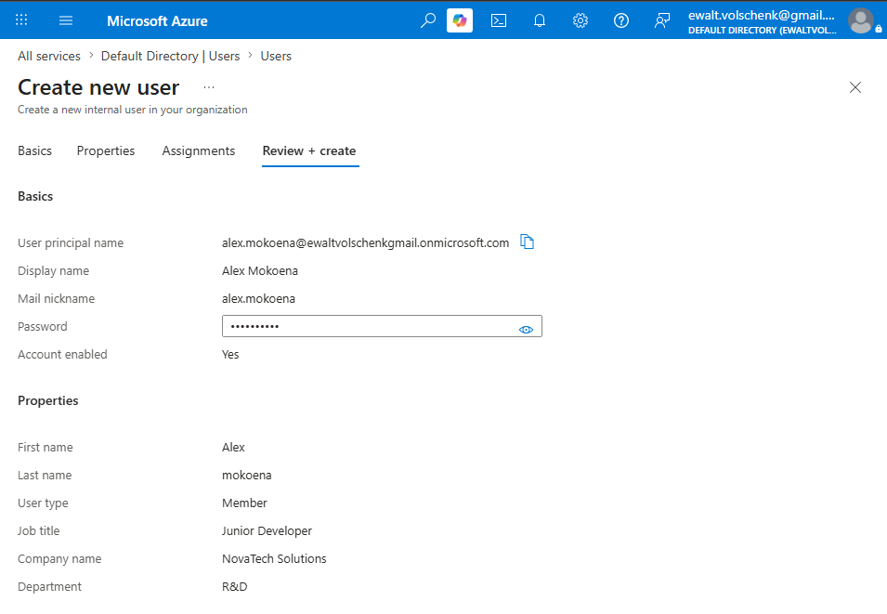
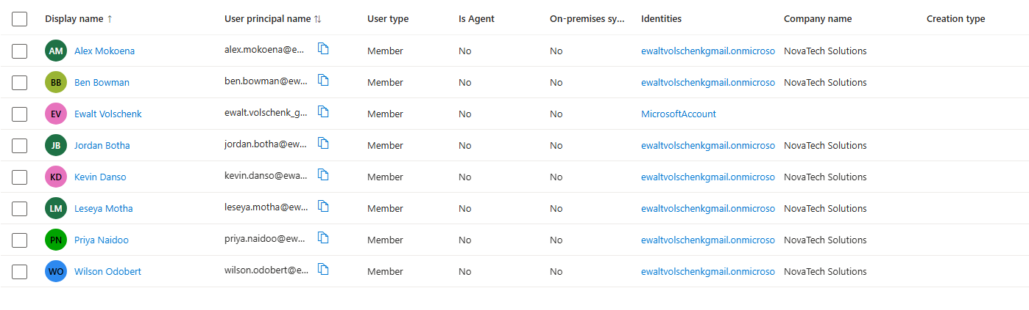
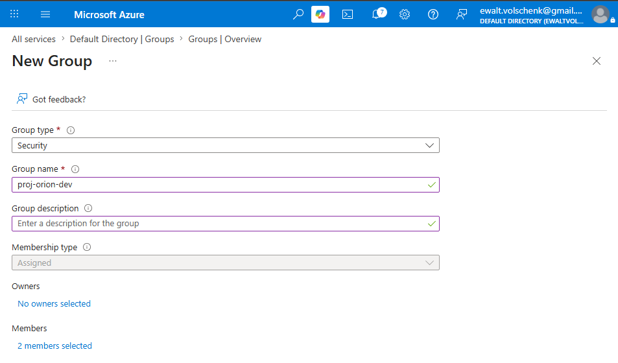
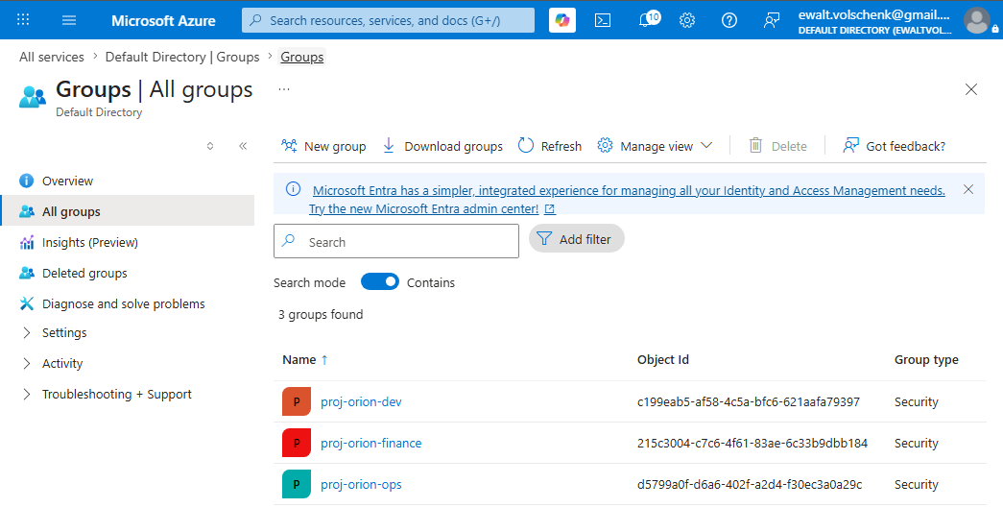
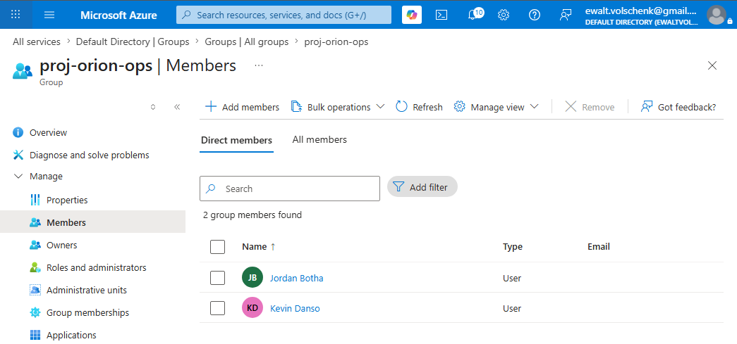
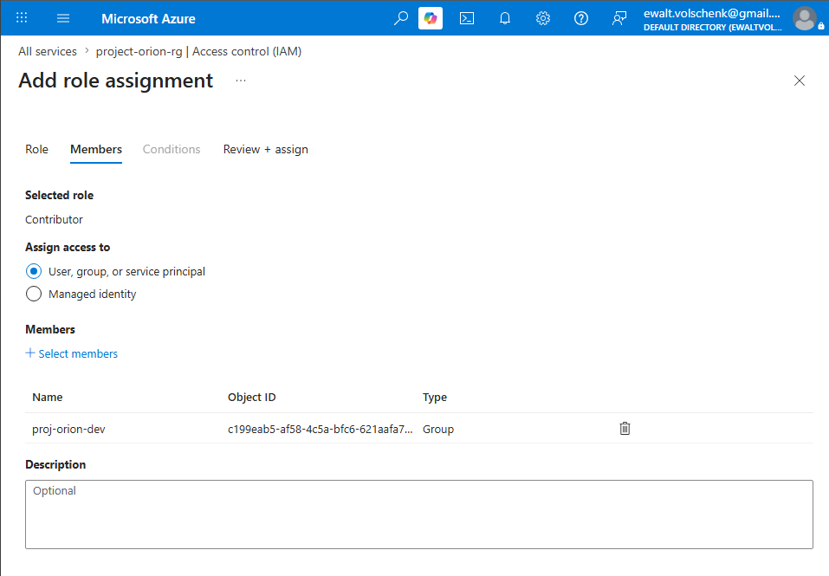
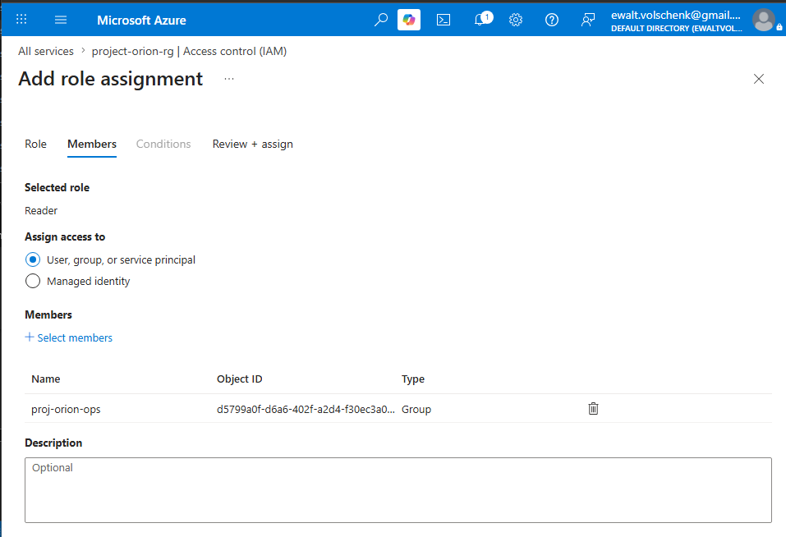
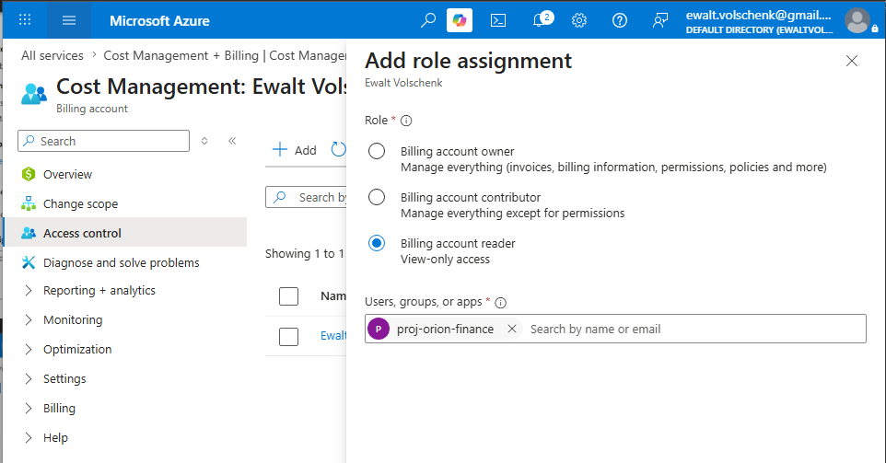
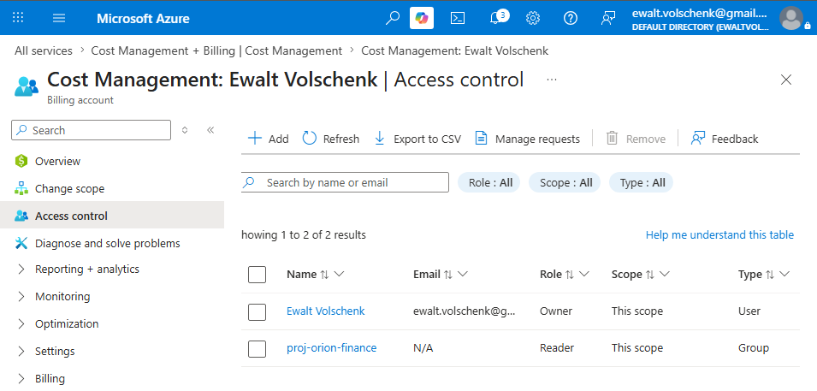

README
What went well: Creating the security groups and adding users to them was straightforward once I understood the difference between Security groups and Microsoft 365 groups.
What was challenging: The Billing scope isn't immediately visible in the Azure portal it's separate from the standard IAM blade used for resource groups and subscriptions.
What surprise me: I was surprised by how detailed the built-in roles in Azure are.
What I would do differently: If I were setting this up for a real company with >100 employees I would use Dynamic group membership instead of Assigned membership.

Summary of identity structure:
Display Name | Username | Department | Job Title
Alex Mokoena | alex.mokoena@ewaltvolschenkgmail.onmicrosoft.com | R&D | Junior Developer
Ben Bowman | ben.bowman@ewaltvolschenkgmail.onmicrosoft.com | IT | Tech Support
Jordan Botha | jordan.botha@ewaltvolschenkgmail.onmicrosoft.com | R&D | Senior Developer
Kevin Danso | kevin.danso@ewaltvolschenkgmail.onmicrosoft.com | IT | Network Engineer
Priya Naidoo | priya.naidoo@ewaltvolschenkgmail.onmicrosoft.com | R&D | Project Manager
Wilson Odobert | wilson.odobert@ewaltvolschenkgmail.onmicrosoft.com | Human Resources | HR Manager

Group Names
Group name | Department | Members
proj-orion-dev | R&D | Alex Mokoena; Jordan Botha
proj-orion-ops | Operations | Ben Bowman; Kevin Danso
proj-orion-finance | Finance | Priya Naidoo; Wilson Odobert

Role Assignments
Group | Role | Scope
proj-orion-dev | Contributor | Resource Group
proj-orion-ops | Reader | Resource Group
proj-orion-finance | Reader (Billing Scope) | Subscription

